Laptop/Desktop Data Transfer Script

Computer Replacement Transfer Script

# Introduction

These procedures provide instructions on how to transfer data and settings between two computers, using scripted automation.

# Setup – Prepare to Use the Script

Before the scripts can be used the following installation process must be completed.

Note: Admin access to the file server may be required for the following step.

Create a shared folder on a file server, and name it XFER. All users will need read and write access to the XFER folder in order to use this script.

Download the CompXfer.zip file from <https://assaabloy.box.com/s/6z73vz0ua6vj3644nv45zx78lp9e7z8j>

Open CompXfer-Master.zip

1. Within the zip file open the folder named CompXfer-Master

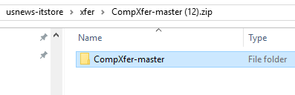

1. Copy the contents of compXfer-master folder into the XFER folder. 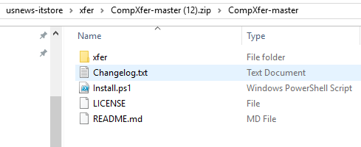

Note: PowerShell needs to be enabled on the computer you are using to install the script. PowerShell does NOT need to be enabled on the file server containing XFER or Computers you are transferring information between.

1. If you have not changed the execution policy for PowerShell do so now.
   1. Open PowerShell

* Windows 10 PC: Click Start > All Apps > Windows PowerShell – right-click and choose Run as Administrator
* Windows 7 PC: Click Start > All Programs > Accessories > Windows PowerShell – right-click and choose Run as Administrator

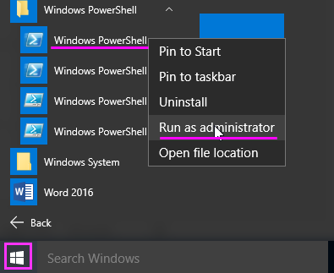

* 1. Type the following command: Set-Executionpolicy RemoteSigned Into the console of Powershell and answer “Yes to all”.
  2. Powershell scripts are now enabled

1. Go back to the XFER folder and right click on install.ps1 and run with PowerShell.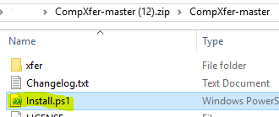
2. When the script completes, the following configuration window will appear. This window will be used to build your configuration file with preferred data and settings to be transferred.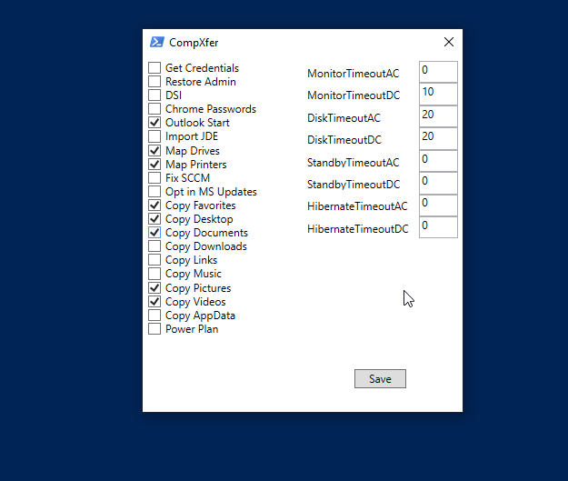

Note: The configuration window can be opened by running the config.ps1 script located in the XFER folder. In this way you may reconfigure the script at any time you choose.

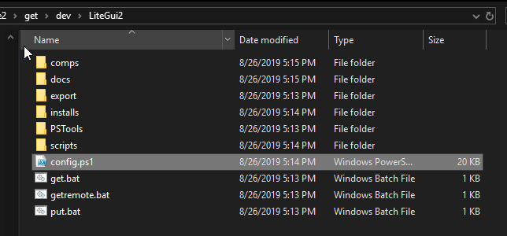

# Using the Script

In order to transfer files and settings a configuration file must be created by using get.bat. This file is located in the XFER folder.

**Running Get.bat**

1. From the source PC open the XFER folder.(You can access the XFER folder by opening File Explorer and entering the path to your shared folder)
2. Run get.bat
3. You will see a Powershell window pop up.
4. Hit ENTER to continue inside Powershell and then hit any key to continue inside the CMD window.
5. Once this is complete a file will be created in XFER\Comps folder.
6. At this point we are finished with the old PC, but do NOT shutdown the old PC.

**Running Put.bat**

Note: The new PC should be imaged, on the domain and signed into by the user

1. Open File Explorer on the new PC.
2. Run the put.bat located within the XFER folder.
3. You will be prompted for the old PC name. For your convenience the last computer that get.bat ran on will be listed, in this way you can simply hit enter.
4. When prompted to allow PowerShell to run, select yes, and input your admin credentials when prompted.
5. Multiple Powershell windows will appear. In this way you can monitor the progress of the data transfer.
6. When the transfer is complete press “Enter” to continue.

**Running Getremote.bat (Optional)**

Note: This step is to be used in place of the normal get.bat procedure under a circumstance in which you would not be physically present at the end users machine.

Note: Users computer must be logged on to when this script is run. This script is used to remotely run get.bat on a user’s computer.

1. Shift right click on getremote.bat and select run as a different user.
2. Type in your admin credentials.
3. Type in the name of the remote computer.
4. A run dialog box will appear on the user’s computer and get.bat will be run.
5. Various windows will briefly appear on the user’s computer.
6. A file will be created in the Comps folder inside of XFER.